Business case

The purpose of this document is to outline how the proposed system solves a real-world problem, project objectives, risk analysis as well as related systems analysis, and the overall project plan – including scope and deliverables.

**1.1 Optimising GBV Incident Reporting**

Gender-Based Violence (GBV) is a prevalent and growing concern in South Africa. South Africa has one of the highest rates of GBV in the world, with daily reports of attacks, harassment, and femicide making the news and showing up in national statistics. People of all ages, genders, and economic standings are victim to this crime, creating a major human rights crisis and societal worry.

A crucial issue in addressing GBV situations is the process of reporting. There is usually either a fear of safety due to the lack of anonymity, a fear of stigma due to societal judgement, mistrust in the existing aid available for victims, or limited access to accessible avenues. In under-resourced areas, they are faced with issues such as lack of responsive and instantaneous support services or having police stations distanced far away from them.  
  
The result of this is under-reported GBV cases, leaving victims feeling silenced as well as preventing support services such as police and NGOs from responding effectively. Due to the lack of reliable reporting channels, data on GBV instances are inadequate, preventing the ability for organizations to design interventions, allocate resources properly, and protect vulnerable groups.

**1.2 Project objectives**

In this section you should list the real-world problem issues that your software intervention will address, e.g.:

* Replace the paper-based note-taking system used by healthcare workers with a digital alternative.
* Ensure that notes cannot get lost, by providing an off-line saving system.
* Provide a central means by which to search through historic notes.

Think of these as the main things that your system will do to address the real-world issue.

**1.3 Problem background**

This is the literature review section of the document. In order for reader to better understand the problem, this section must provide an overview of the problem area using existing sources, e.g. web references, conference papers, white papers, patents or journal articles. You are required to use proper APA referencing. The idea with this section is that if a reader has no knowledge of the real-world problem area; this section should provide them enough background to understand the issue, e.g. an overview of the process that healthcare workers use when visiting patients in remote areas.

**1.4 Related systems analysis**

When researching what other GBV software systems are readily available in South Africa, I came across three widely used applications – Bright Sky SA, GRIT, and Namola.

Bright Sky SA is a mobile application available for both Android and iOS devices and was created during the COVID-19 pandemic when gender-based violence in homes sky-rocketed. It is focused on helping victims or bystanders report GBV incidents through the app. The app also offers a questionnaire section, enabling users to understand what kind of GBV they are experiencing, the different support services that are available for them, as well as a range of case studies for educational purposes. Figure 1 demonstrates the Covert Mode screen which promotes anonymity for users on the app.

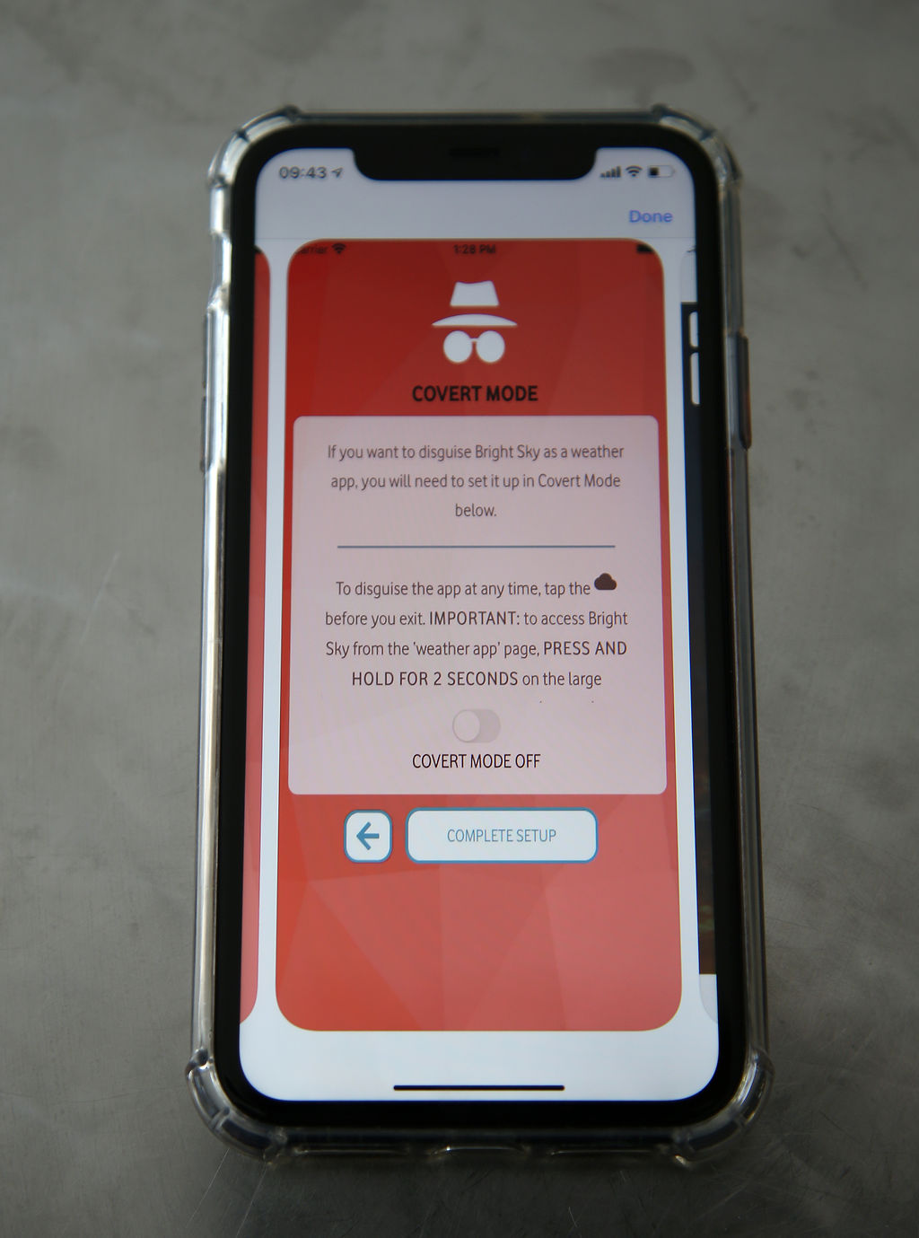

Figure : Bright Sky SA Covert Mode screen

Features that we would like to incorporate into our system:

* Users are not subject to data costs when using the app due to the zero-rated feature.
* Privacy of personal user information.
* The dedicated support and resources section provided for the user.
* ‘Covert’ mode – allowing users to stay anonymous.

Features that we would like to avoid:

* This app is not designed for emergency situations. We would like to have this option for users who find themselves in a dangerous situation.
* It acts more as an information hub than a direct reporting tool. Sometimes an abundance of information and resources can be overwhelming for users – we would like to have a balance of both an information and reporting section.
* The app does not act as a direct channel to authorities such as police and NGOs. It shows the user where they can find help near them, but we would like users to have that direct access to help services.

GRIT (Gender Rights in Tech) is an Android and iOS application that provides a secure and confidential way for survivors to report a GBV crime, as well as allowing them to have access to support services. It contains a panic button, a database that can store up to ten years of evidence, and a chatbot (as seen in Figure 2) that aids victims in speaking about their situations without fear of stigma, allowing them to gain some useful legal and health advice.

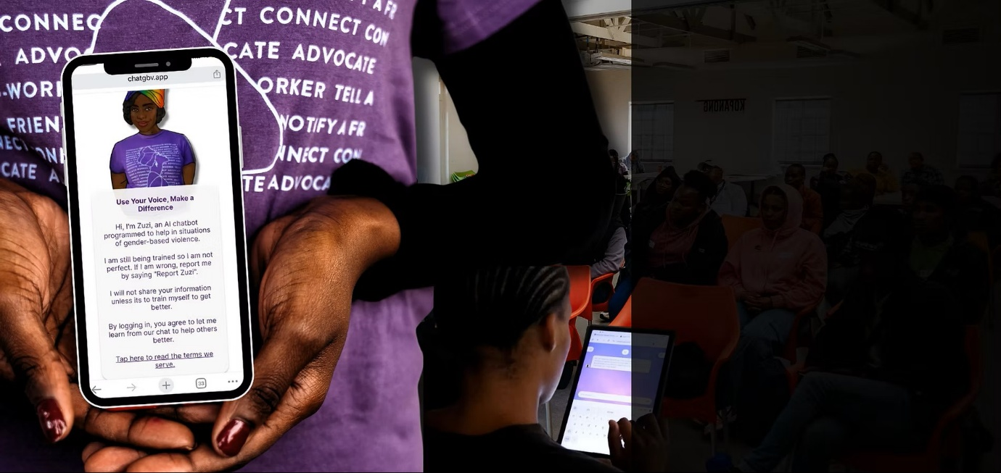

Figure : GRIT Chatbot Screen

Features that we would like to incorporate into our system:

* The panic button for immediate location tracking and emergency response.
* Ability of long-term storage in a secure manner.
* Accessibility through the ‘no cost’ approach in regard to the app and data usage

Features that we would like to avoid:

* The use of a centralised vault for evidence storage. It would be beneficial for the user to store evidence on their local device.
* High dependency on emergency armed response. Our aim is to provide a more inclusive approach for users to either contact emergency services or their trusted contacts.

Namola is accessible to mobile Android as well as Apple users and provides instantaneous access to emergency services. The press of a button will enable the user to access services such as the police, fire department, ambulance, and traffic officers. This application ensures a quick and reliable outcome for those who find themselves in a crisis. It does not only specialise in GBV, but many other situational incidents – such as fires, wellbeing, and safety. Figure 3 shows the community screen included in the Namola application, allowing for users to stay updated on any reports or incidents in and around their city.

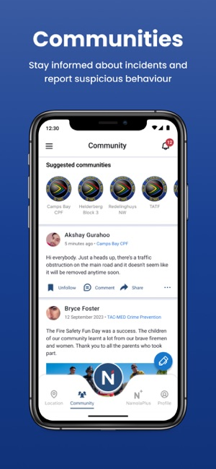

Figure : Community screen on Namola

Features that we would like to incorporate into our system:

* Sharing user location to emergency services
* SOS button for immediate response from emergency services
* ‘Sensitive Mode’ which allow users to stay anonymous in their reports.

Features that we would like to avoid:

* The broad emergency response rather than focusing on GBV crimes does not align with the goals of our application.
* Namola Plus, a paid subscription which provides private armed response, limits the accessibility that we are aiming to achieve with our application.
* The spotlight on armed response, with no access to NGO support, can result in a GBV survivor feeling as if they cannot report their situation in a safe and discreet manner.

**1.5 The project plan**

A project, or project management plan is a document that contains a project scope and objective. Typically, it will be represented as a Gannt chart to make it easy to convey information.

A project plan should answer these questions:

* What are we delivering?
* How will we deliver on time?
* Who is working on the project and in what role?
* What miles stones/goals are set for project?

Before you can start your project plan you need to understand (at a minimum) the following things:

* What does your client expect/need?
* The goals of the project
* What is the decision-making process of your client, and how will they approve and review the project work?
* Who is the sponsor?
* Who is the project manager?
* What other stakeholders are important?

As project manager you also need clarity from your client to know exactly what their expectations are. Sometimes this requires you to ask some hard questions to get a clear understanding.

Questions that may impact a project plan:

* How will you collect feedback?
* Who has the final sign-off?
* What is the project deadline?
* What is the availability of the project team?
* How often will the teams meet for feedback?
* Does your team have a history of successful projects?
* What can prevent the project from being a success?
* What tools and methods of communication will the team use?

*Your project plan should include the following information (at the very minimum):*

* *Project and client name (make one up)*
* *Delivery date and version*
* *Milestones and deliverables*
* *Clear task durations with start and end dates (using a Gantt chart)*
* *Dependencies for tasks (i.e., should anything happen before this task can happen).*

**1.6 Risk Analysis**

During the process of brainstorming our app, we have found potential risks that would affect the app and those who use it. When risks are identified, it would then need to be decided how those risks will be handled. Therefore, it is important that we identify some of these risks to ensure it is easier for us to determine which risks are preventable or are of higher importance. These risks can be divided in four categories:

**Acceptable risks:** Fake reports would fall under this category as it would be too costly and resource-heavy to fully prevent them and would possibly deter genuine users from using the app. Overall, it would be more beneficial to accept that there will be a few fake reports which would be outweighed by the genuine ones.

**Avoidable risks:** Loss of data is an avoidable risk due to the preventable actions that can be taken such as ensuring backups are frequently occurring and stored in multiple locations securely. Another risk could be the lack of awareness of our app, which can be avoided by implementing awareness drives where communities know more about it.

**Minimizable risks:** Although privacy violations are not completely avoidable, there are steps that can be taken to minimize the impact or occurrence of them. Using encryption and secure authentication can reduce privacy violations and protect the confidentiality and integrity of user data.

**Transferable risks:** In the context of our GBV app, a big transferable risk would be the legal or compliance issues. Instead of having an incident where we would break the law or have an oversight, we would rather transfer that responsibility to NGOs and or legal advisors who have the expertise to manage it in a professional manner.

**1.7**

# References

GRIT. (n.d.). *Our Tech*. Retrieved from Grit GBV: https://www.grit-gbv.org/technology

Lyndon Julius. (2024, July 31). *GRIT introduces AI chatbot to UCT staff and students*. Retrieved from UCT News: https://www.news.uct.ac.za/article/-2024-07-31-grit-introduces-ai-chatbot-to-uct-staff-and-students?utm_source=chatgpt.com

N.A. (2020, November 30). *Everyday Heroes: Fighting against violence*. Retrieved from Victim Empowerment Programme: https://gbv.org.za/bright-sky-sa/

Namola. (n.d.). *Namola Safety App*. Retrieved from Namola: https://www.namola.com/

Vodacom. (n.d.). *Popular Pages*. Retrieved from Vodacom zero-rates Bright Sky SA gender-based violence awareness app | Vodacom Group: https://www.vodacom.com/news-article.php?articleID=7594#:~:text=JOHANNESBURG%20%2D%20As%20part%20of%20its,services%20such%20as%20Bright%20Sky.